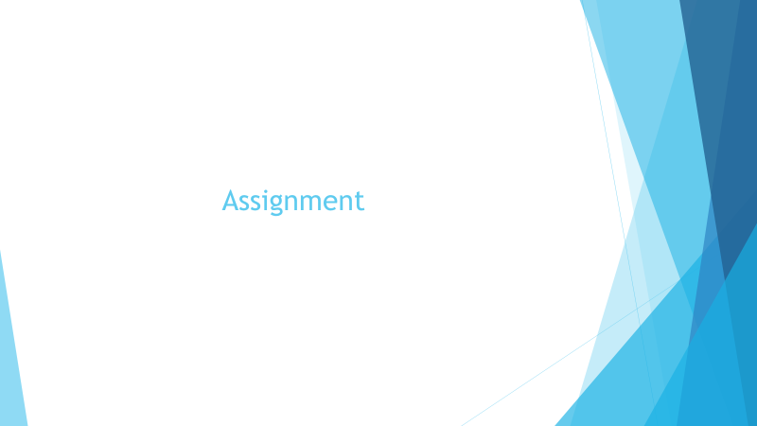

Please write the robust path for below components.

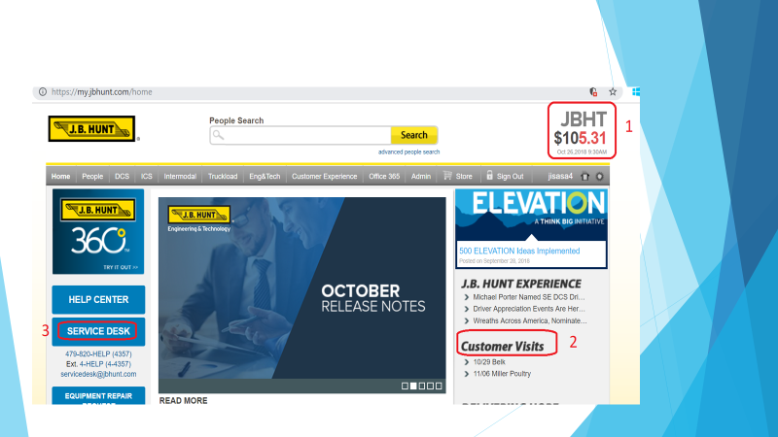

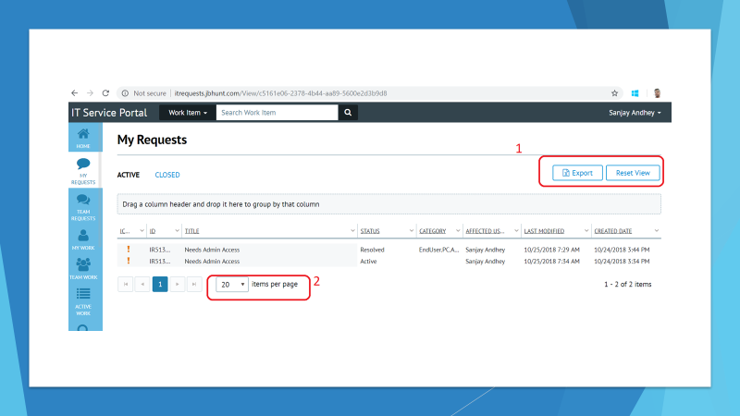

**Solution:**

//div[@class ='symbol']

//div[contains(text(),'JBHT')]

//div[@class='symbol' and contains(text(),'JBHT')]

//div[@class ='price' and contains(text(),'$')]

//h2[@class ='widgettitle']//img[@src ='/wp-content/themes/workplace/images/customervisits.png']

//div[contains(text(),'SERVICE DESK')]

//a[@class ='k-button pull-right btn btn-default btn-grid-export']

//a[text() =' Export']

//a[text() ='Reset View']

//span[@class ='k-input']

Absolute Path ( very dynamic- Not recommended)

//*[@id="article_52146_28497164_1.0"]/div[2]/a/div/div

Relative Path:(More Robust)

//div[contains(text(),'SERVICE DESK')]